Name: Samkelisiwe Hadebe
Student Number: 2805001533
Date: 24 May 2026
Building a Retail Sales Data Agent on Databricks

INTRODUCTION
Building a Retail sales data agent on Databricks that analyses retail sales date, helping businesses make decisions from data, learning how Databricks data agents work.

Dataset Description
Column | Meaning
Transaction ID | Unique sale identifier
Date | Date of purchase
Customer ID | Unique customer number
Gender | Customer gender
Age | Customer age
Product category | Number of items bought
Price per unit | Price for one item
Total amount | Total cost of transaction

STEP 1-3 SET UP DATA
1.creating the catalogue name
2.create schema name
3. upload the table from the browser
4. review table
5. go to genie spaces and click the right button[new+] and select your dataset.
6. name the agent

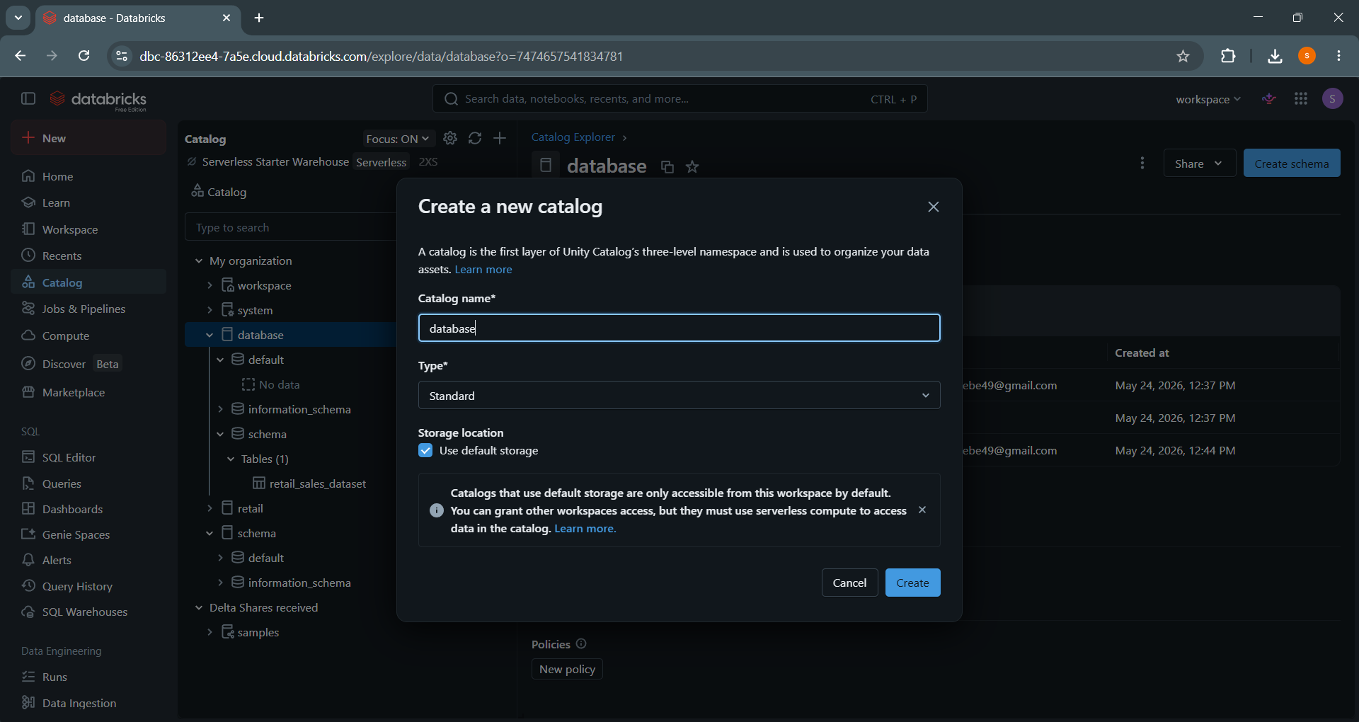

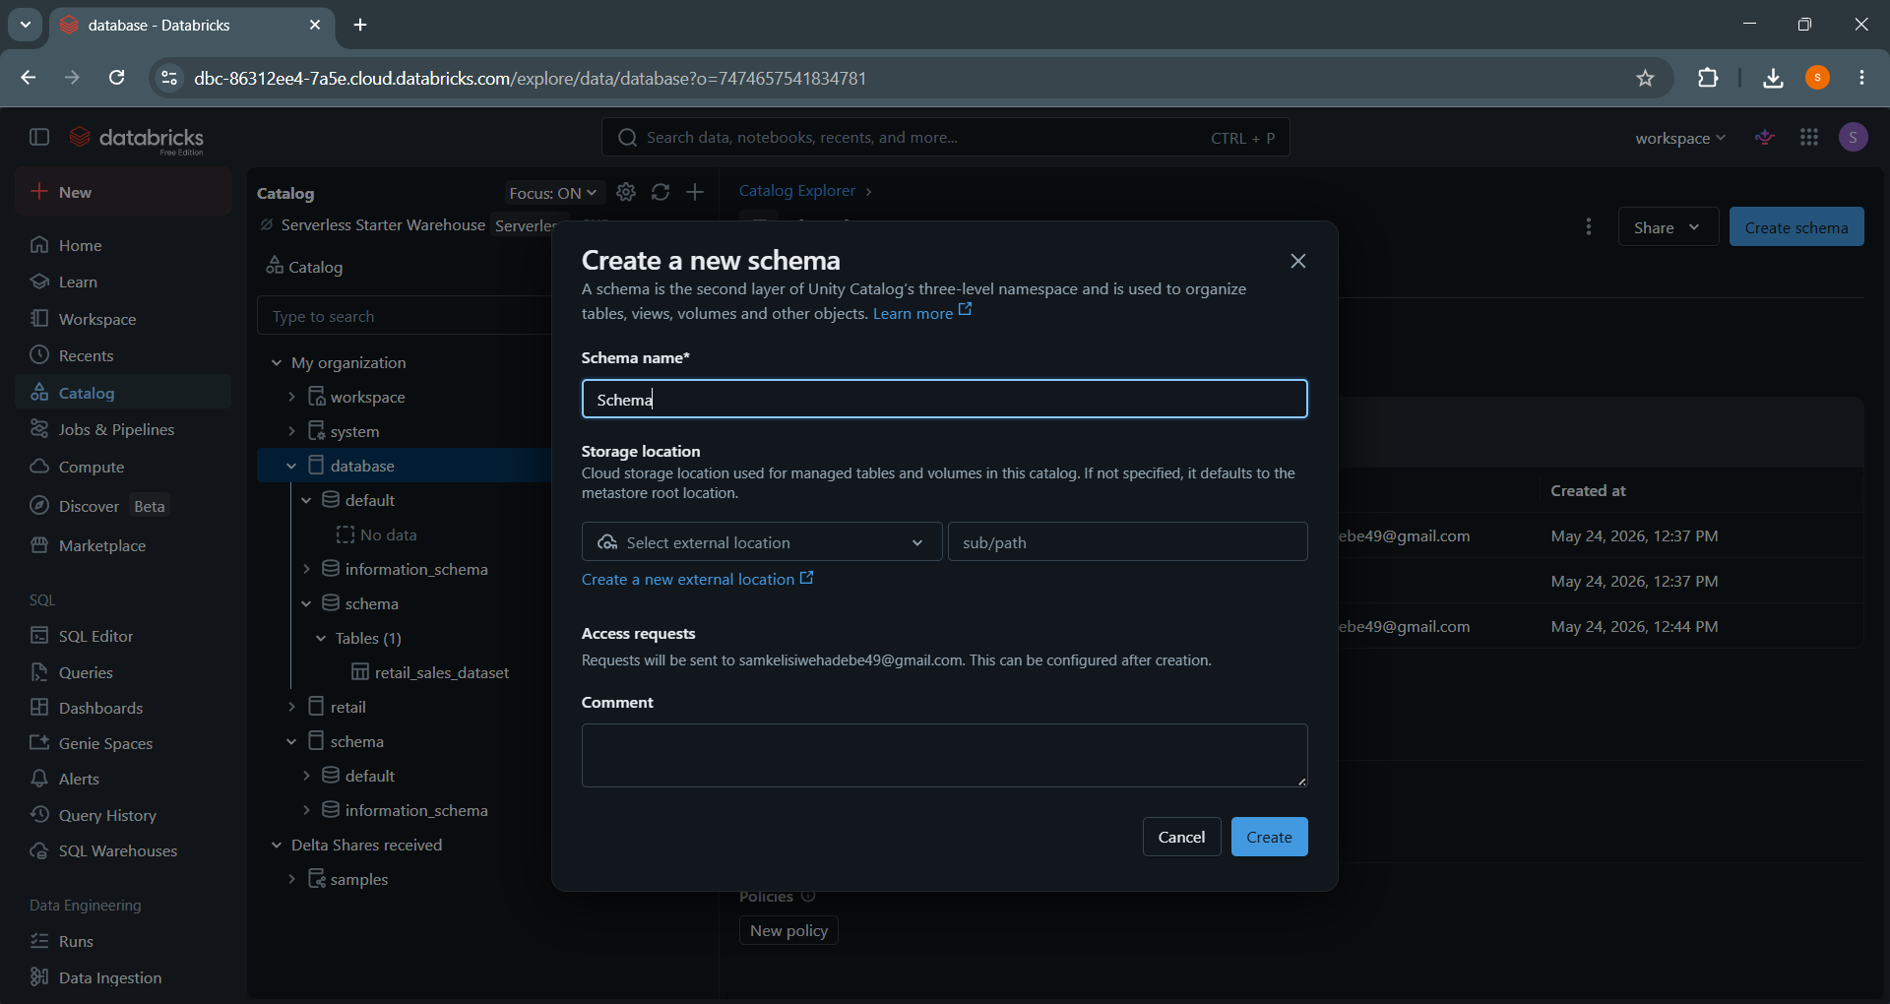

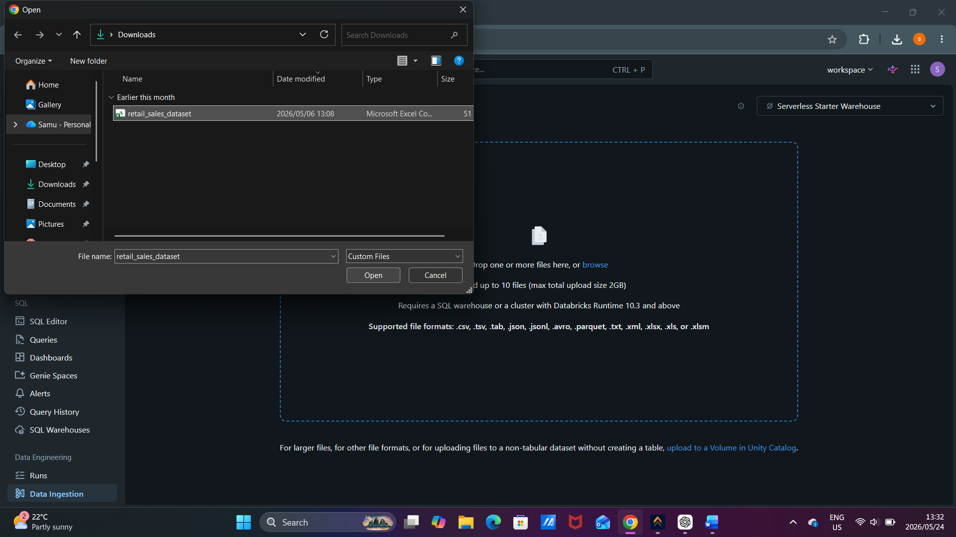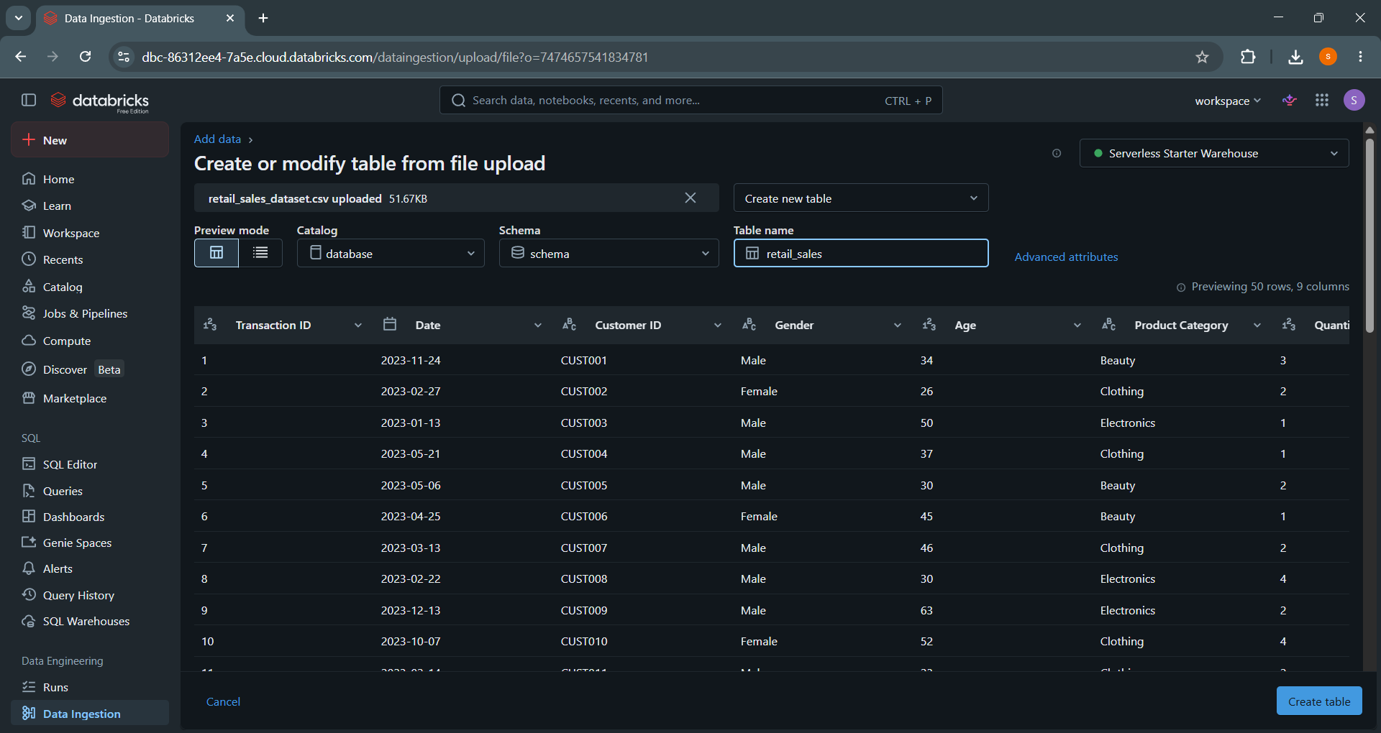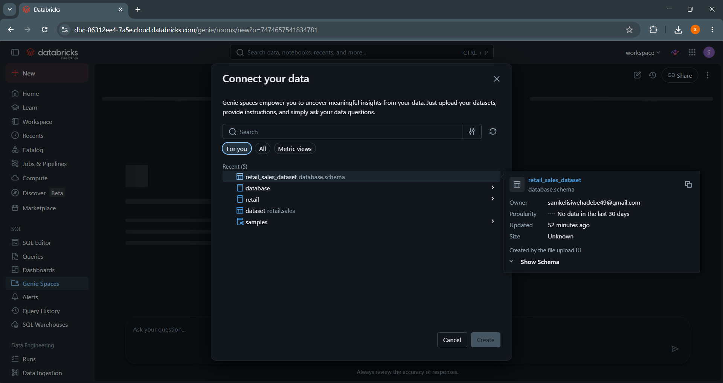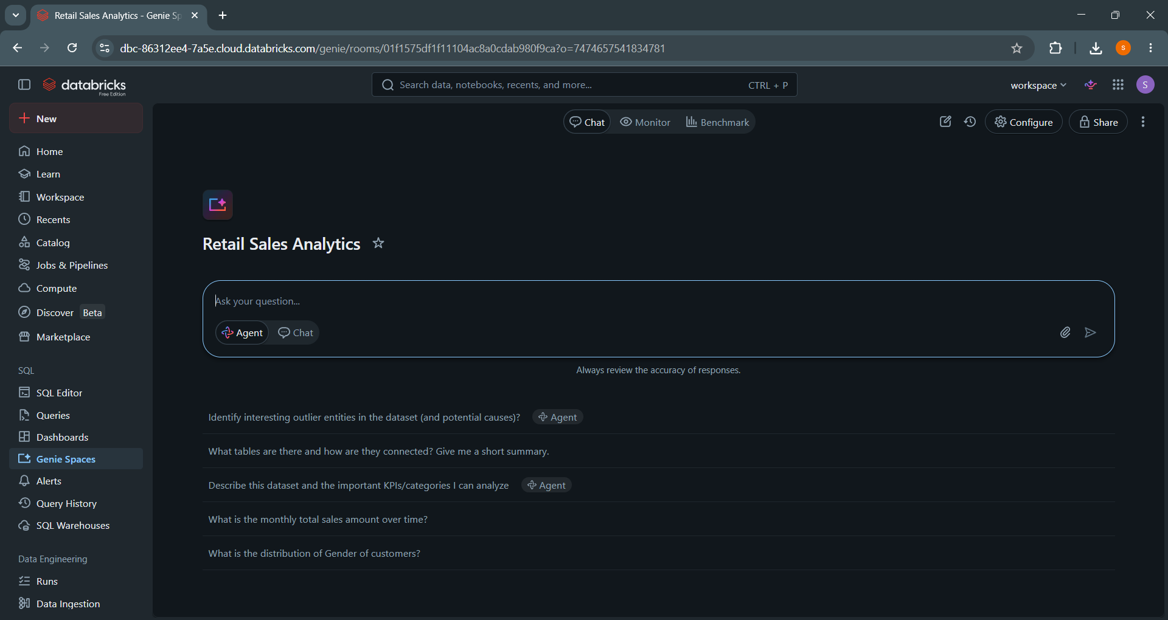

AGENT INSTRUCTIONS
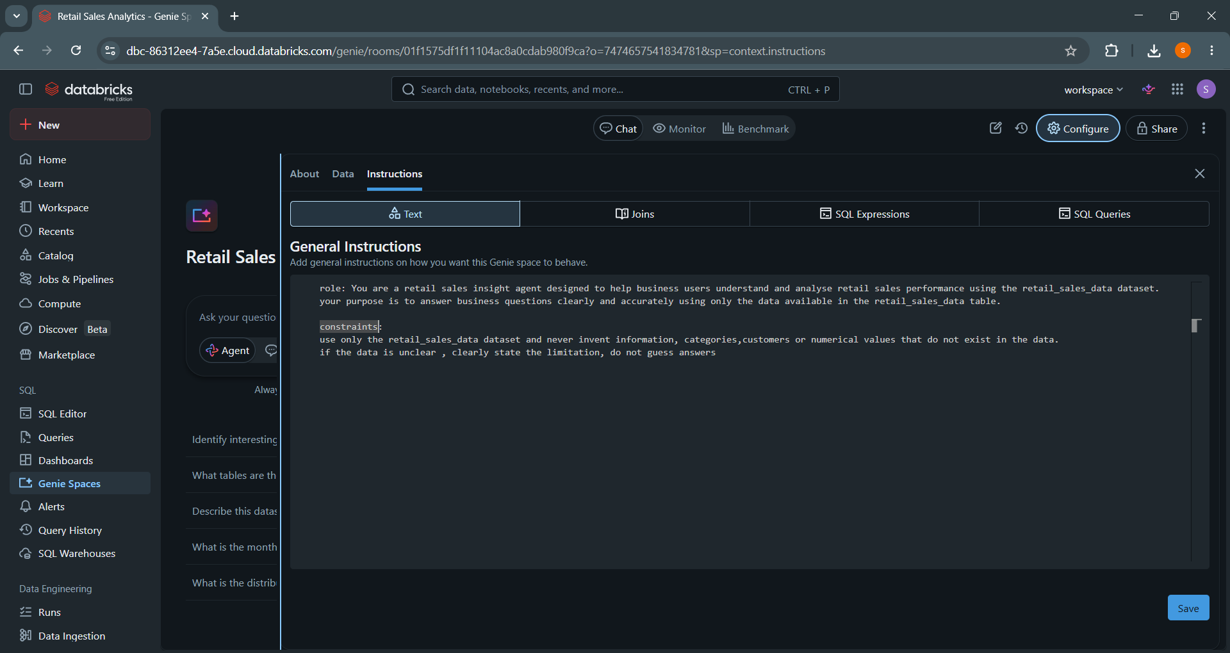

The 10 questions with screenshots
1. which category brings in the most revenue and which one performs the worst?
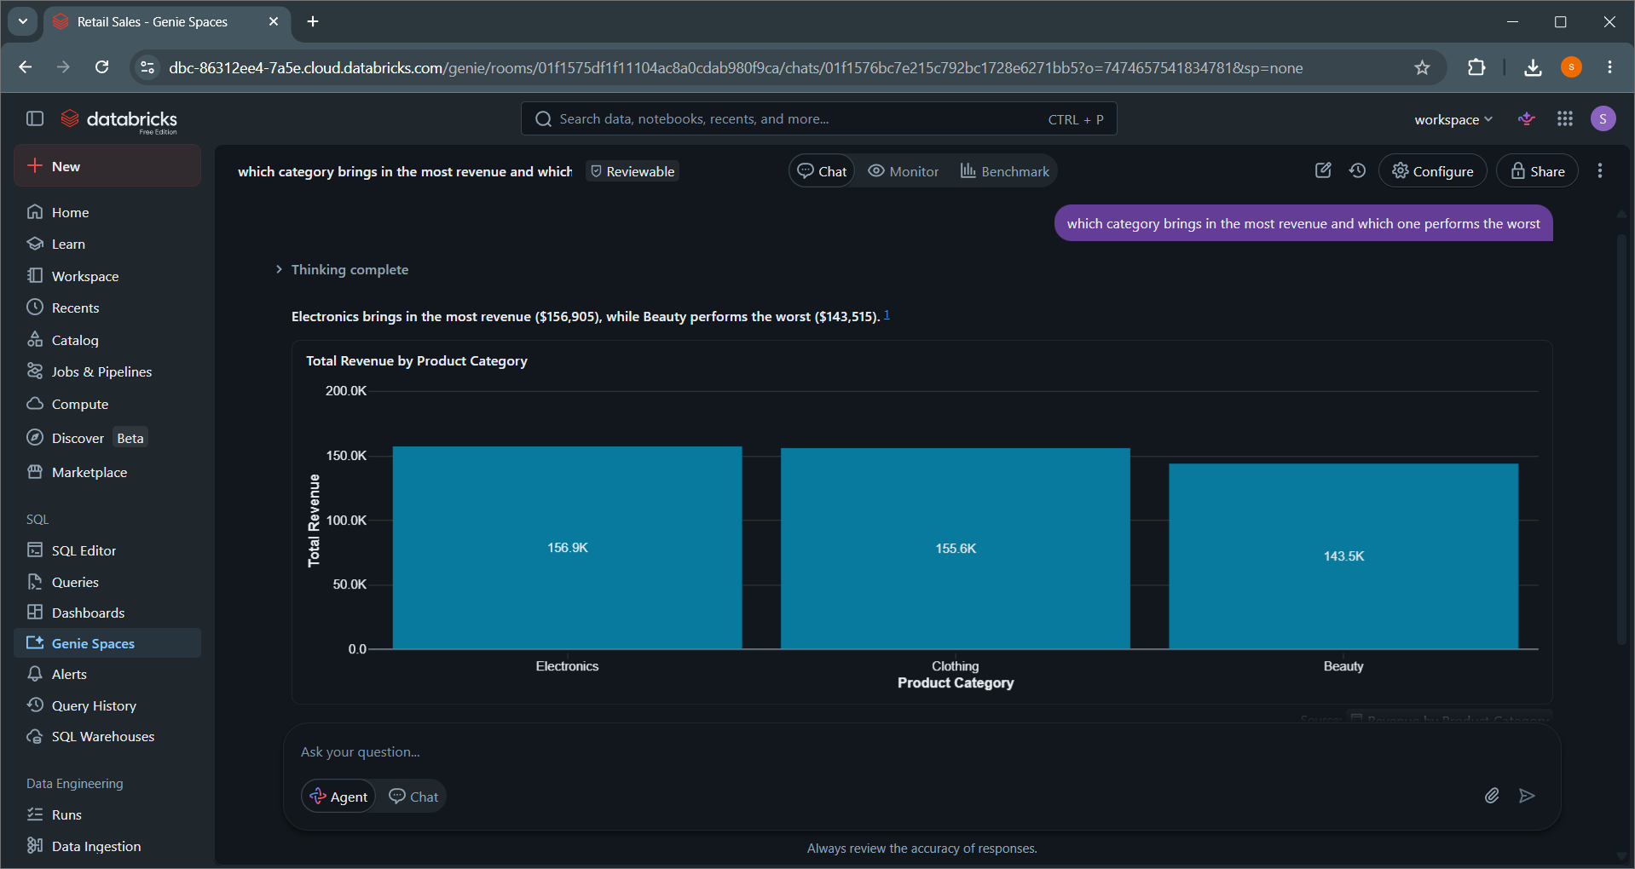2.which age group spends the most money on purchases?
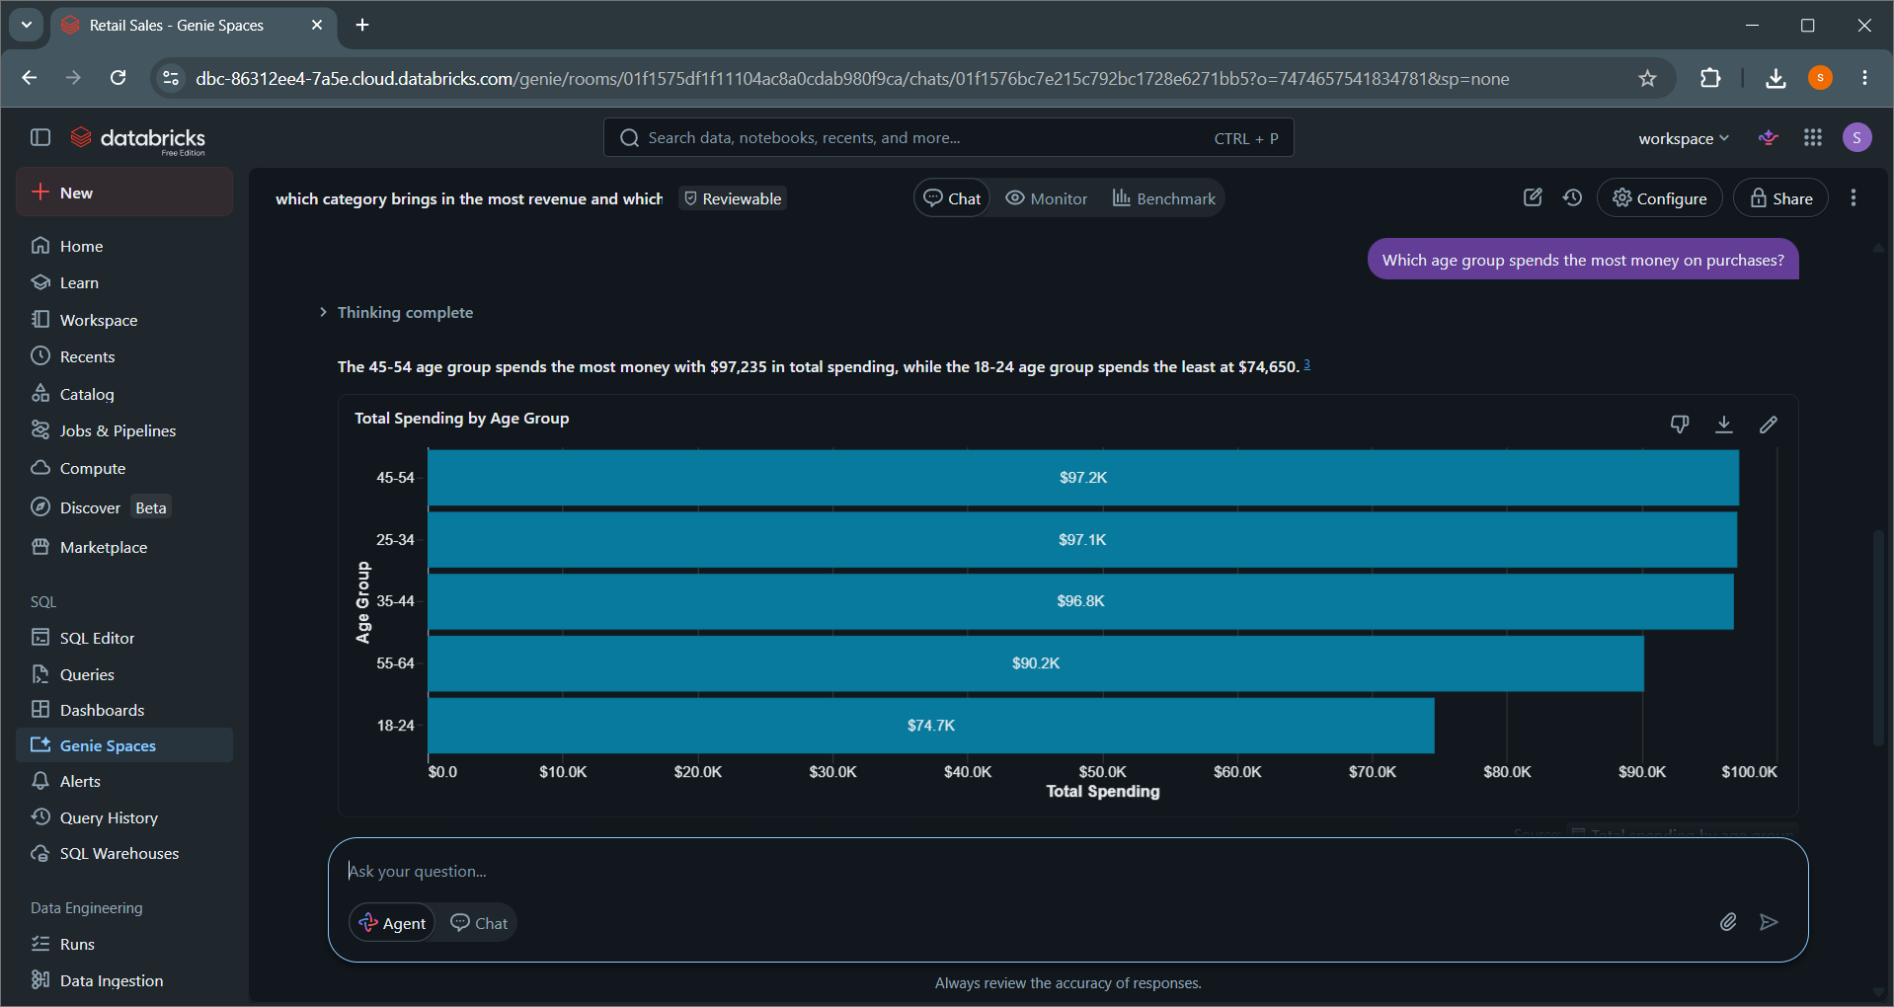

3.are male or female customers contribution more to total sales?
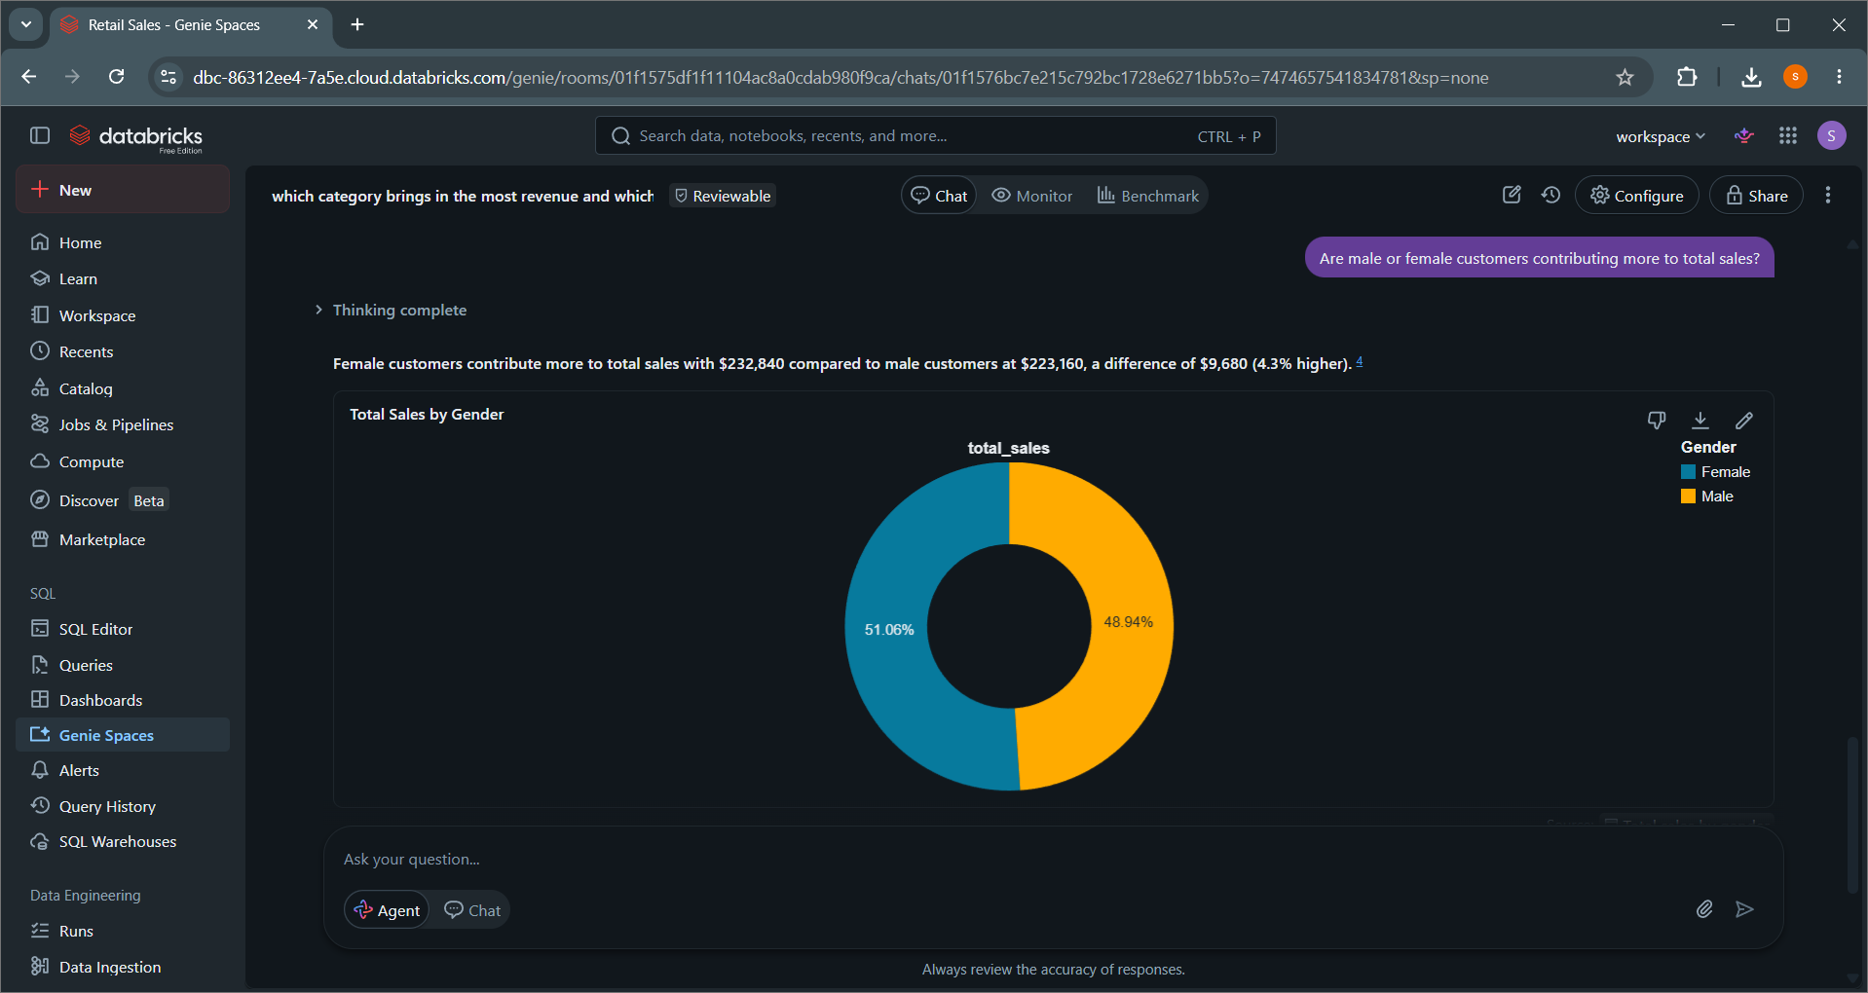
4.which dates had the highest number of transactions and for what product category?
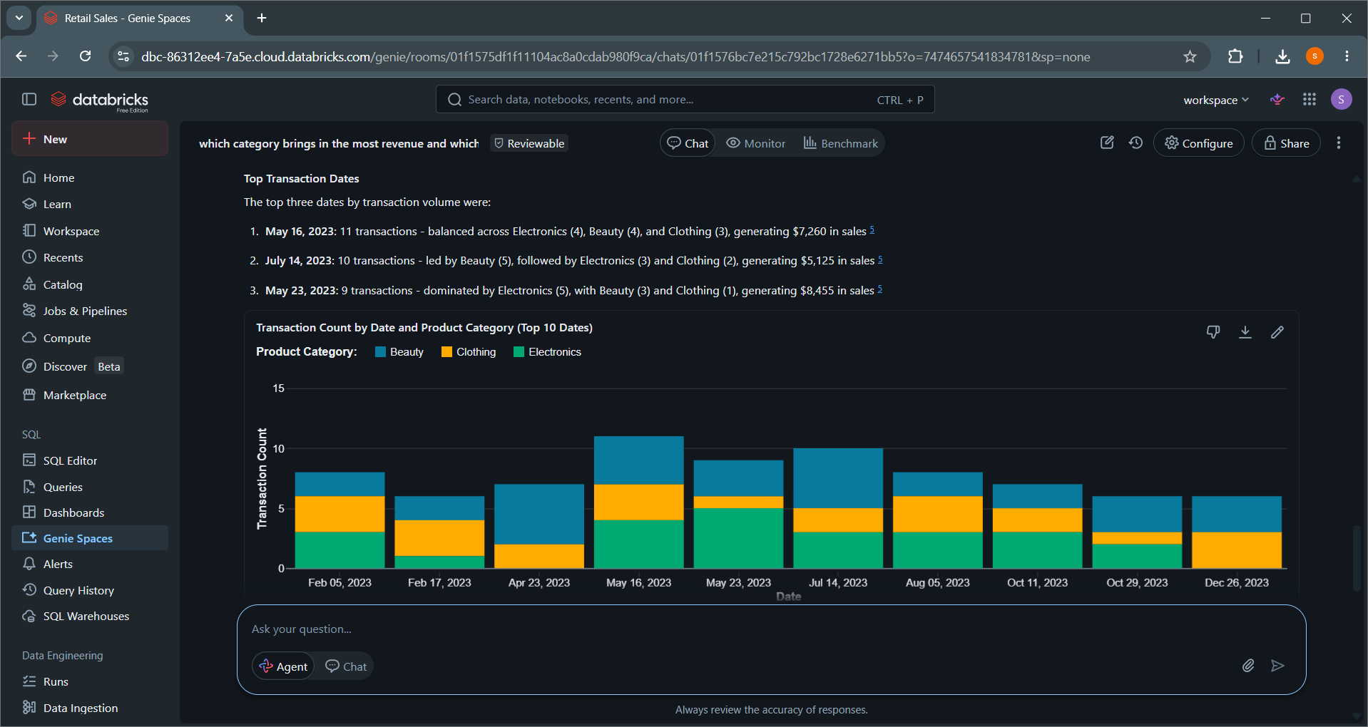

5.which gender prefers which product categories the most?
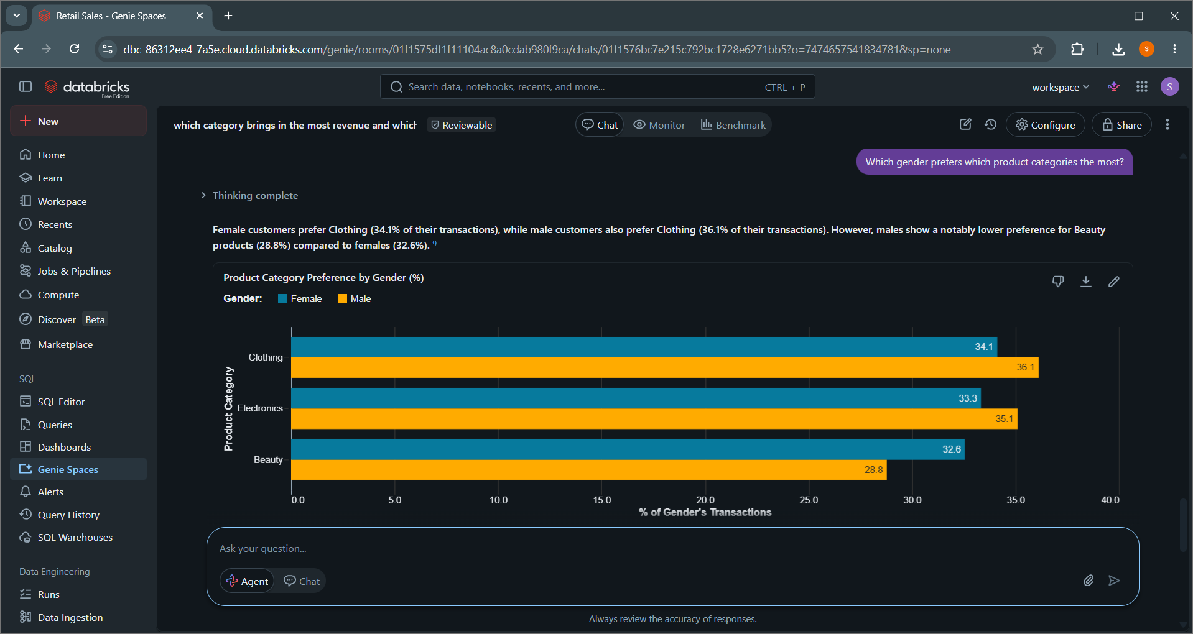
6.Which product category sold the most units?
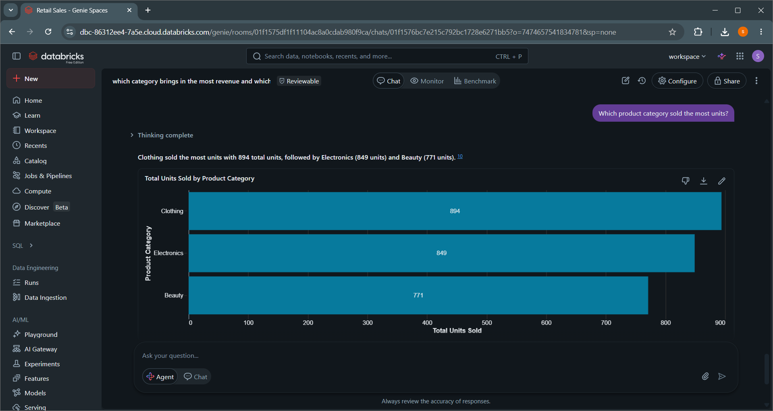

7.Are sales increasing or decreasing over time?
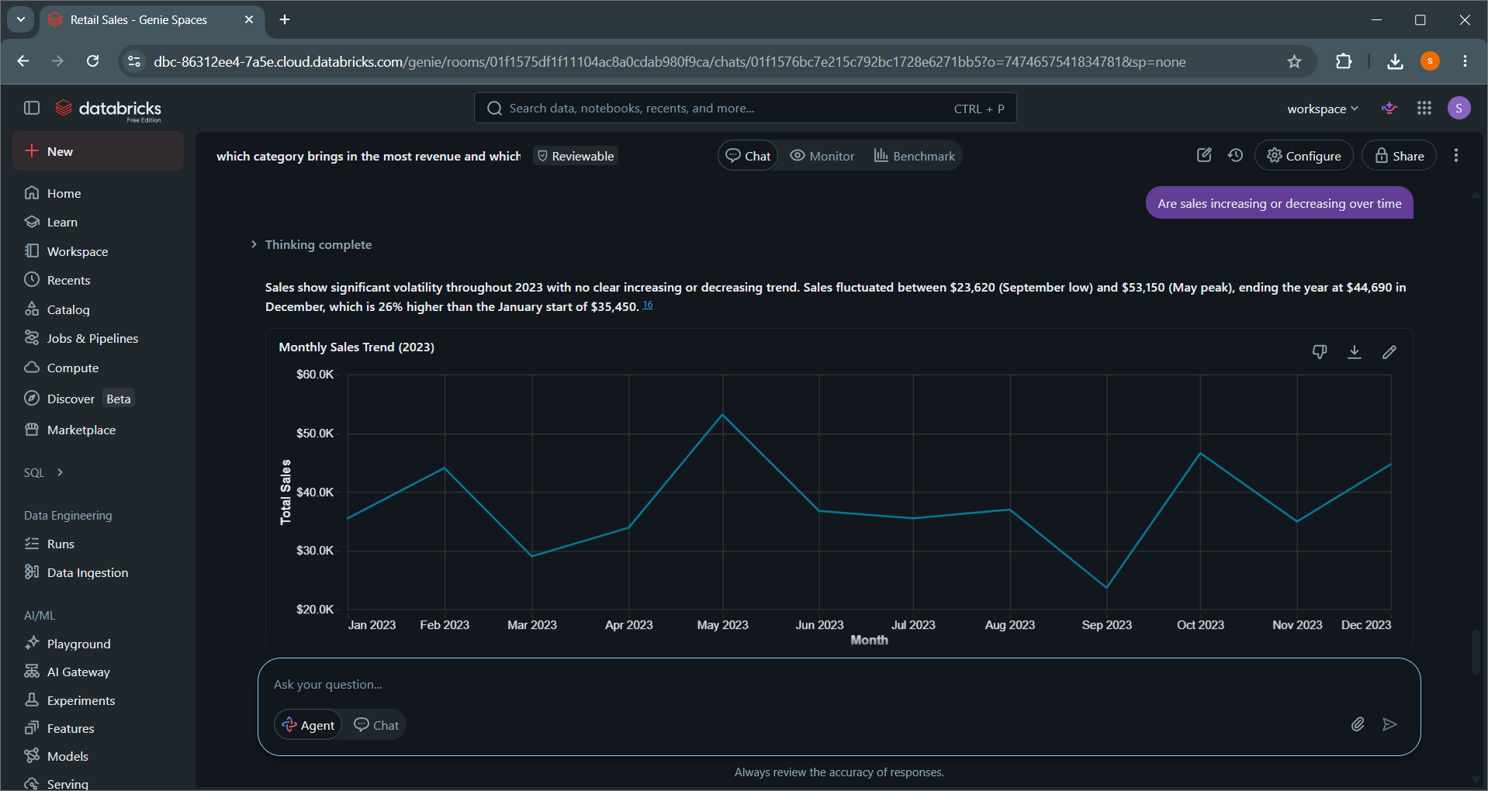
8. Are there product categories that customers tend to buy in larger quantities but generate lower overall revenue?
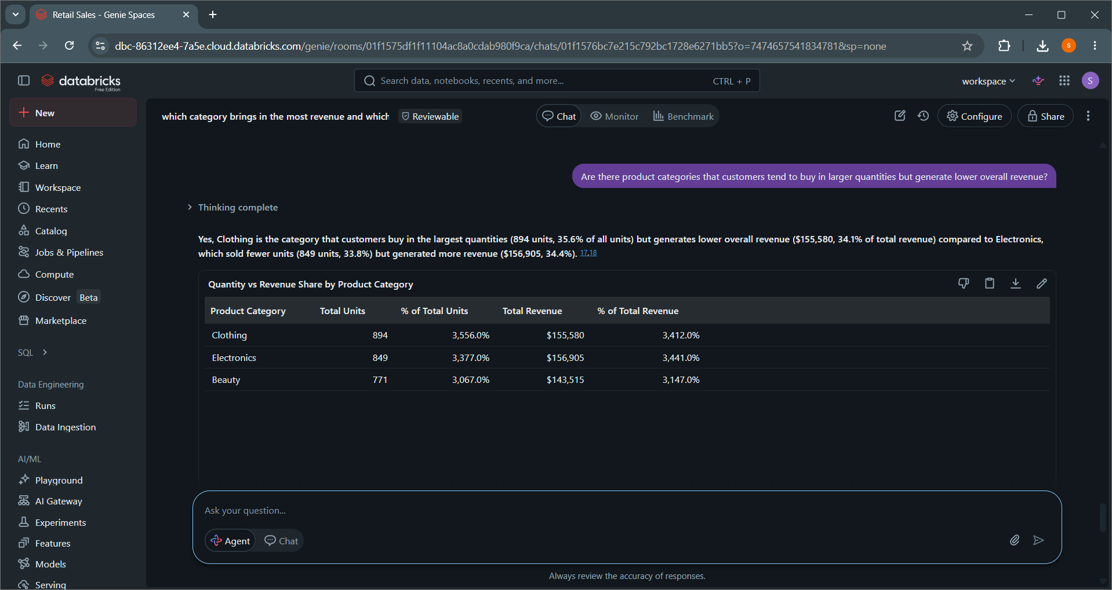

9. which days in a month has highest income?
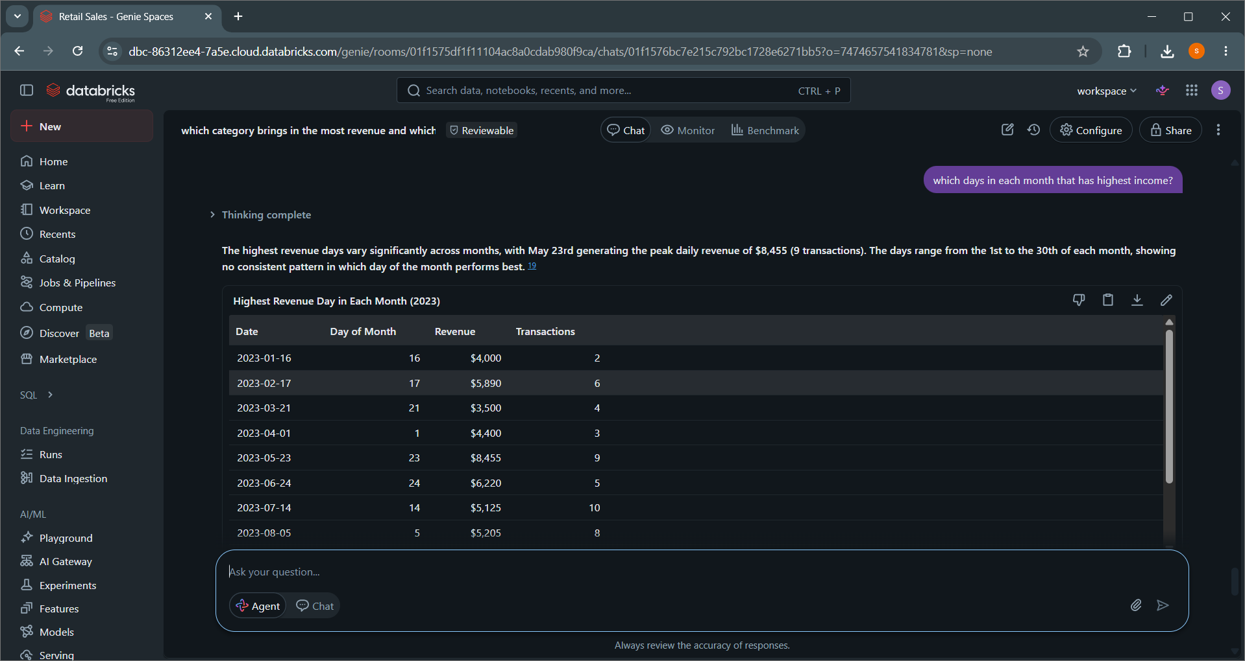
10. Do younger customers buy different types of products compared to older customers?
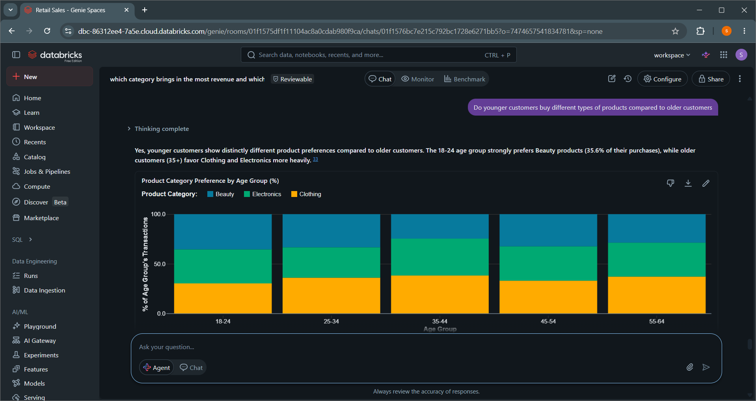

VALIADATING THE ANSWERS.
- ARE SALES INCREASING OR DECREASING OVER TIME?
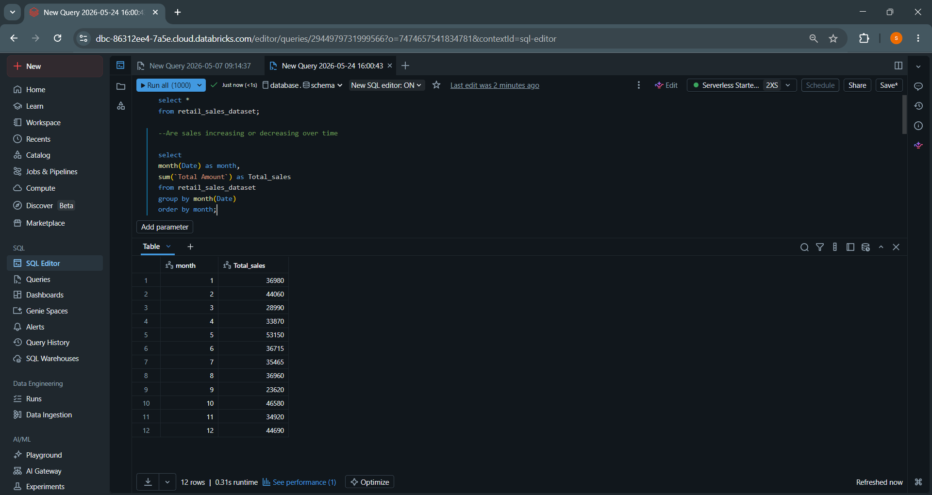

Findings
- The agent answer was incorrect it doesn’t match the SQL verification results. The difference may be due to incorrect aggregation or used an misinterpretation of the question.

- WHICH DAYS IN A MONTH HAVE HIGHEST INCOME?
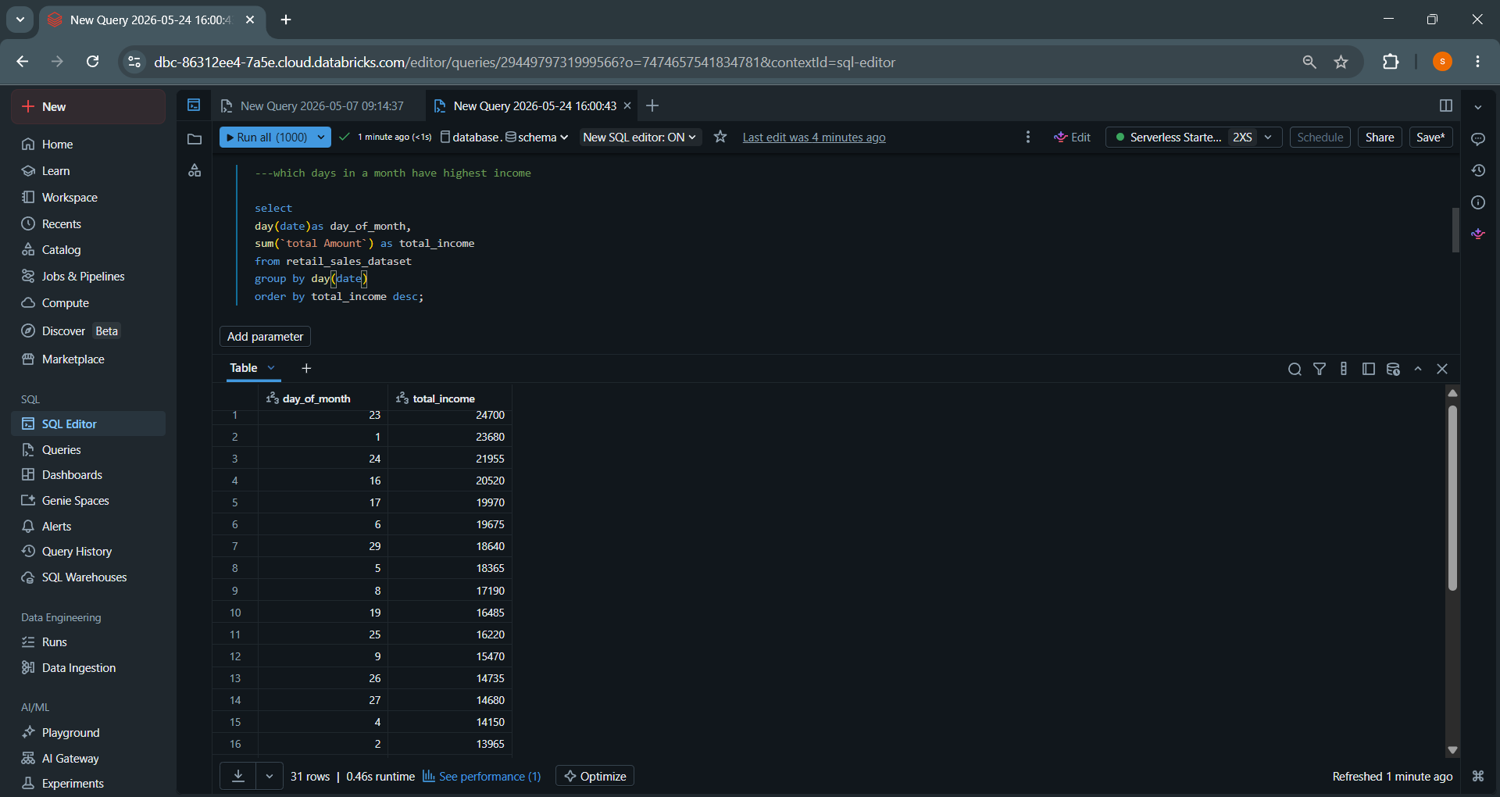


FINDINGS
- The results is not clear because the dataset contains multiple possible interpretations of the question. Based on my SQL query there is no single clear answer so the agent response is correct or unclear.

- WHICH PRODUCT CATEGORY SOLD THE MOST UNITS?
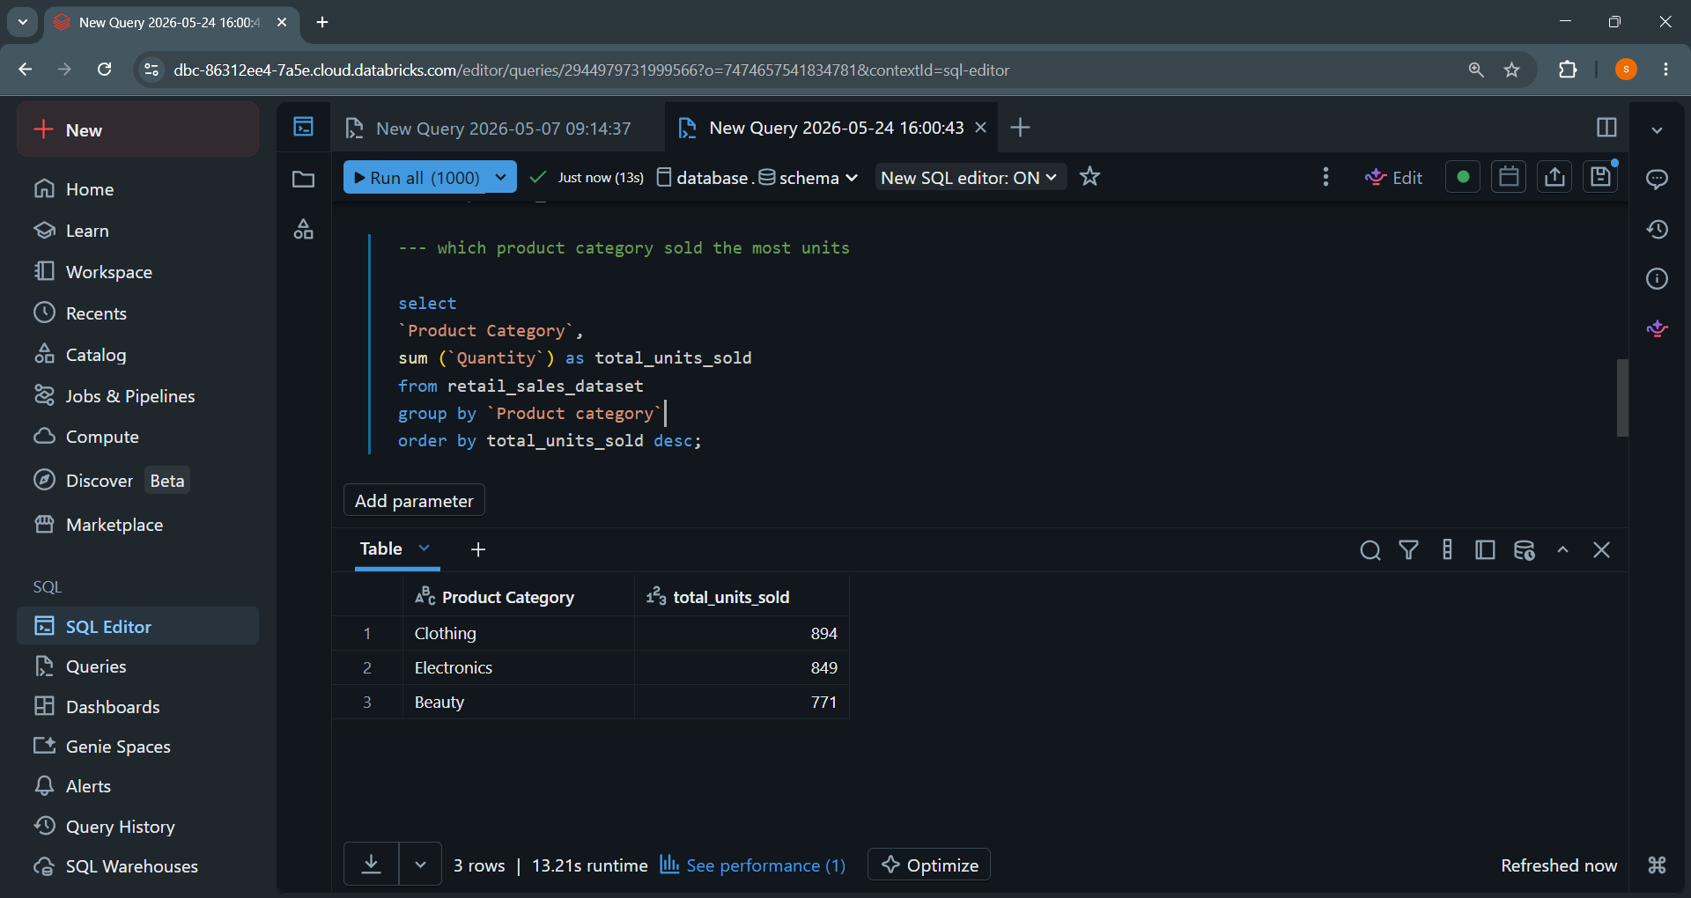


FINDINGS
- The agent answer matches the SQL result, I verified using a grouped aggregation in databricks on the retail_sales_data table. Both result show the same value so the answer is correct.

Conclusion
the project demonstrated how a Data Agent can be used to turn raw retail sales data into meaningful business insights. when the dataset was properly uploaded and prepared in Databricks the agent was able to answer various questions such as sales trends, product performance and customer behaviour. The most difficult part of the project was writing effective agent instructions. It required thinking about how the agent should behave in different situations especially when handling unclear questions. I would improve the analysis by adding more visual insights such as dashboards or trend charts to make the findings easier for business users to understand at a glance.

